Center for Advancement of Child Health (CAtCH)
NIH CHRCDA K12 Program
Request for Applications
*Letter of Intent due November 1, 2022
*Applications due January 18, 2023
*Appointments beginning June 1, 2023

Duke Center for Advancement of Child Health (CAtCH) recruits outstanding early-career physician-scientists and supports them through a structured, mentored, career development program to become independent pediatric researchers. The program represents a “launchpad” for physician-scientists’ careers, providing a critical 1–2-year period of protected time to develop research skills, publish in high-impact journals, and apply for and secure external funding to successfully transition to independence.
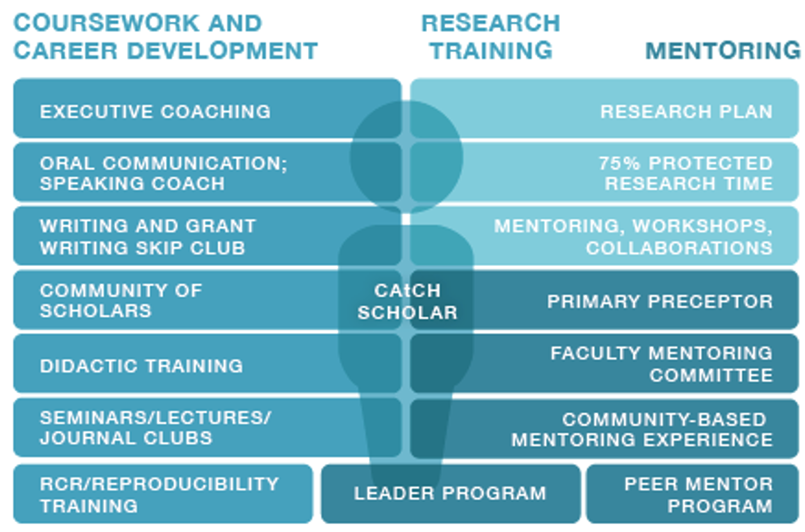

Program Summary
Leadership | Ann Reed, MD and Corinne Linardic, MD PhD (MPIs)  Mai Elmallah, MD MS (Training Director)
Granting Mechanism | National Institutes of Health, Eunice Kennedy Shriver National Institute of Child Health and Human Development, Child Health Research Career Development Award (CHRCDA) Program (K12-HD105253)
Candidates | Junior faculty, or medical fellows in their final year of fellowship training; primary appointment in the Pediatrics Department; must hold an MD or MD/PhD and completed residency in Pediatrics
Appointment Duration | Minimum of 1 year; Maximum of 2 years
Research Focus | Research focused on and directly relevant to child health  - Note for the 2022-2023 cycle, in order to fulfill NIH programmatic goals, the program will be placing an emphasis on candidates pursuing basic/translational research.
Next RFA: | LOI due Nov 1, 2022; Full application due Jan 18, 2023; Appointments starting Jun 1, 2023
Website | Duke Center for Advancement of Child Health (CAtCH)
Contact | Katie Misuraca, PhD (katherine.misuraca@duke.edu)

Candidate Requirements
- Candidates will be required to have an MD or DO degree (or MD/DO and PhD), be US Citizens or permanent residents, have completed postgraduate residency in pediatrics, be no more than 4 years after attaining board eligibility in their subspecialty, have prior research experience, and be committed to a research-intensive career as an academic pediatrician.
- Candidates will hold a junior faculty appointment (Medical Instructor or Assistant Professor) in the Department of Pediatrics or be in their final year of pediatrics subspecialty fellowship (with plans to transition to a faculty position in 2023). External candidates will also be considered—division chiefs are encouraged to consider this opportunity when recruiting external faculty candidates. External candidates should also submit a LOI and full application according to the process outlined below.
- Research Focus: For 2023 appointments, in order to balance our research portfolio and address NIH programmatic goals we are only requesting applications from individuals conducting basic or translational research related to any area of child health.
- Scholars will be selected for up to 2 years of support. One to two appointments will be available in 2023, beginning June 1, 2023. There is some flexibility with appointment dates – applicants’ proposed timeline for appointment should be discussed with department leadership prior to applying.
- Individuals selected for this honor will be designated CAtCH Scholars, and once appointed, will receive up to $100,000 per year for salary and fringes consistent with the institution salary scale. The Scholar will be required to devote at least 75% of full professional effort (9 person months) to K12-related research and activities, will receive funds for research-related expenses ($25,000 per year), and will be expected to secure independent external funding by the end of their 2-year appointment period (or before).
*Please discuss with your division chief if you are interested, prepare a LOI (see below), and CAtCH leadership will be in touch with you to discuss the program prior to preparation of a full application.

*CAtCH encourages applicants from all backgrounds, including individuals from diverse racial, ethnic, and cultural backgrounds; individuals from groups that are under-represented in science and medicine; first generation college graduates; students from financially disadvantaged backgrounds; women; and individuals with disabilities of any form. See here for NIH definitions of underrepresented in medicine.

Mentors
Candidates are required to identify a mentor or mentors prior to applying. Mentors are required to provide a letter of support for the candidate as part of the application (see Application Components below). Please review the list of approved CAtCH Mentors here. If an applicant wishes to work with an alternative mentor not included in the list, they may propose it in their application.

Letter of Intent (required)
A letter of intent is required before submission of a full application. LOI is due November 1, 2022, emailed to PediatricResearch@duke.edu and should include the following:
- Name, current position and department/division, expected position as of June 1, 2023
- Brief statement of research focus and research goals (2-3 sentences)
- Name of primary mentor
- Brief statement of career goals (2-3 sentences)
- Preliminary timeline for external grant submissions
Leadership will review Letters of Intent on a rolling basis until Nov 1, 2022; once received and reviewed, we will reply to confirm whether submission of a full application is recommended. If necessary, we will schedule a meeting to discuss the program. If at any time, a potential applicant would like a meeting to discuss the program, we will be happy to accommodate.

Application Components

1. NIH Style Biosketch for Applicant
Please provide an NIH Style Biosketch, conforming to all requirements as specified by NIH for non-fellowship applications (click here for a blank template). Instructions can be found here.

2. Research Project and Career Development Plans (2 pages total, Arial 11-pt font, single line spacing, margins no less than 0.5 inches)
- In no more than 1 page, please provide a description of your research project planned for your CAtCH appointment; use the format of a Specific Aims page.
- In no more than 1 page, please provide a description of your career goals, a career development plan during your K12 appointment and beyond, and a specific plan/timeline for acquiring independent external grant support prior to the end of your K12 appointment period.
3. Mentor Letter and Biosketch
Instructions for the mentor: Please provide a letter of support for the candidate and detail your commitment to the candidate’s career development, the specific role you intend to play in their career development, and your prior experience with mentoring. Please also provide an NIH style Biosketch.

4. Letter of Support from your Division Chief
Instructions for the division chief: Please provide a letter of support for the candidate, confirming their ability to devote at least 75% of their full professional effort to K12 research and related activities if selected and detailing their clinical commitments during their potential K12 period of support. Please reach out to CAtCH leadership with any questions.

Submit Application
Please combine the above components into a single pdf, with the following naming convention: “applicant last name_CAtCH_2023”. Email the application by 11:59pm January 18, 2023 to: PediatricResearch@duke.edu.

Review Criteria
Briefly, selection criteria will include applicant career goals and commitment to a career in academic research, timeline for securing external funding, research focus to align with programmatic goals discussed above, mentor selection, and research plan. Applicants may be contacted to schedule interviews with CAtCH leadership, which would also be considered in the overall evaluation of each application.

