Unified Program for Therapeutics in Children (UPTiC)
2023 Request for Applications
*Applications due March 20, 2023

The central mission of the Unified Program for Therapeutics in Children (UPTiC) is to train pediatrician-scientists to lead the development, implementation and evaluation of novel prophylactics and therapeutics for pediatric populations. By bringing together the remarkable breadth and strength of basic and clinical sciences at Duke University and the University of North Carolina at Chapel Hill, we have developed an integrated, pediatric research-focused training program available to all pediatric fellows centered on the fundamentals and practical aspects of research and development of therapeutics for children. Complementary strengths of the individual institutions offer synergy to the research and training missions of this program. This program fosters a fertile environment that spans departments and schools with an exceptionally broad range of training opportunities and mentors across each University, located just 9 miles apart.
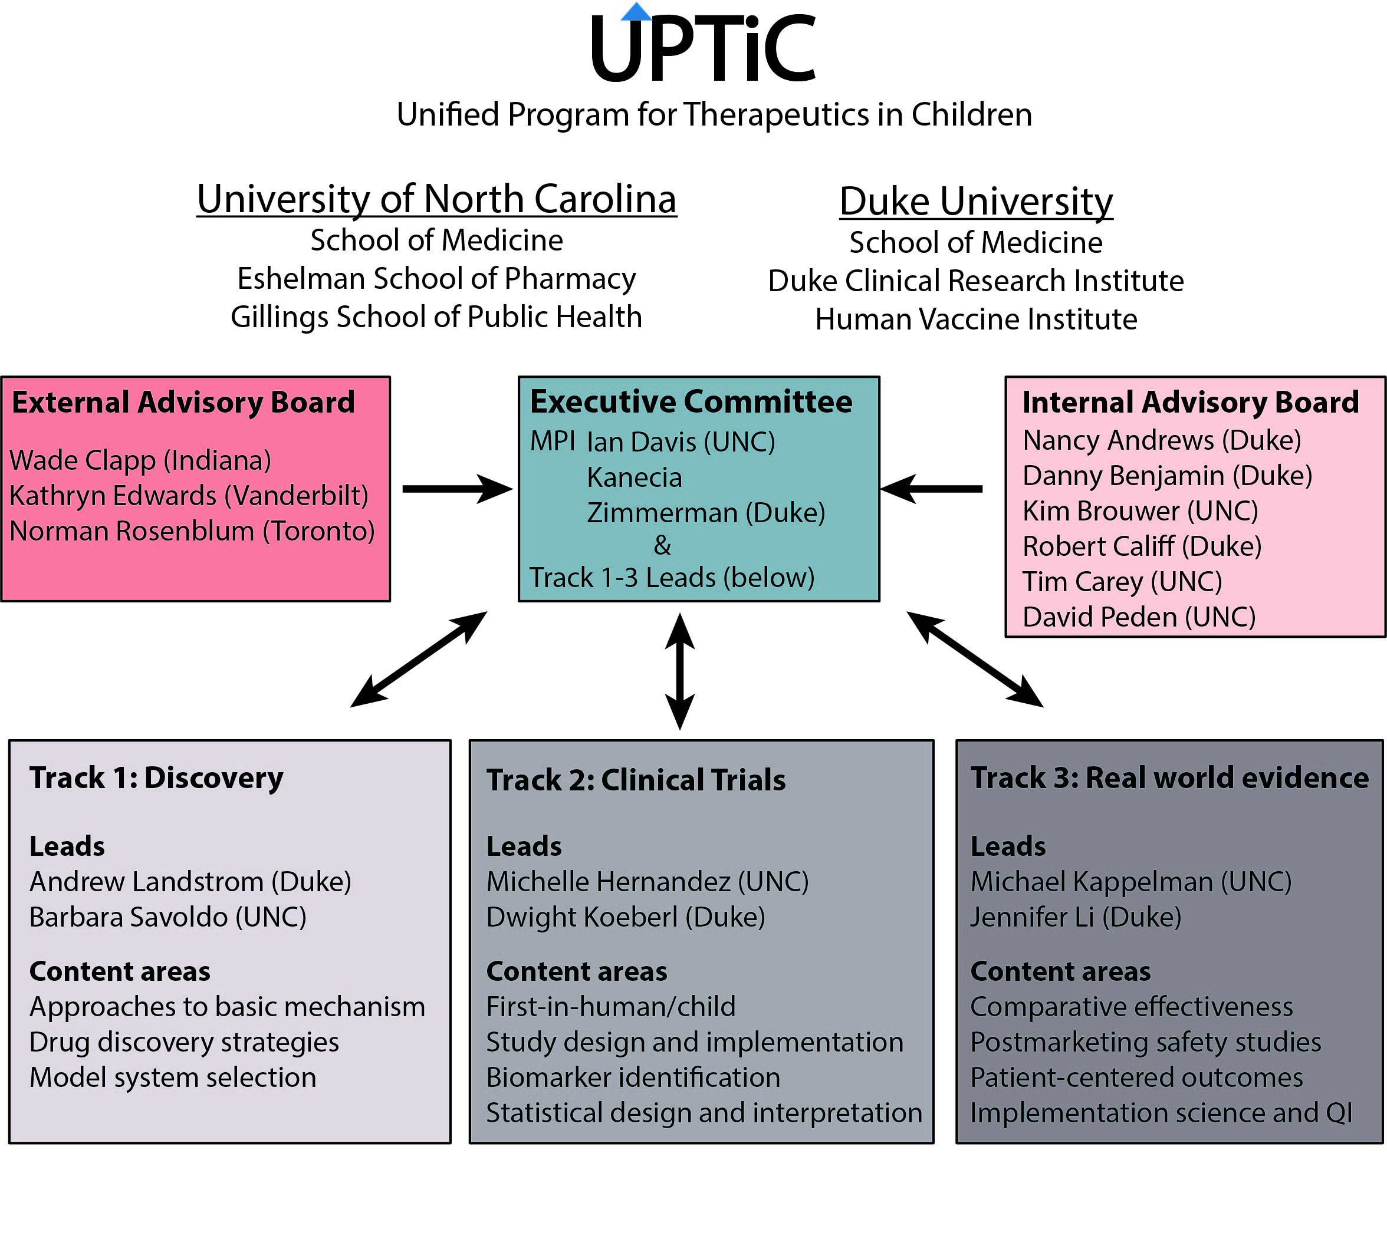
UPTiC Training Plan Overview
Key elements of the training plan include:

Core Didactic Training:
1. UPTiC Colloquium (monthly, including didactics, journal clubs and works-in-progress discussions)
2. UPTiC Symposium (annually)
3. Department of Pediatrics Research Forums (Duke and UNC)
4. Opportunity for Advanced Degrees
5. Mandatory Participation in National Meetings
6. Presentation skills training
7. Ethics Training and Consultation
8. Grant writing skills development
Research Mentorship and Scholarship Oversight
1. Mentor and Research Project Selection
2. Scholarship Oversight Committee
3. Individualized Development Plan
4. Meetings with Mentor(s), SOC, and UPTiC MPIs for continuing oversight

Candidates
Candidates will be required to have an MD or equivalent degree, be US Citizens or permanent residents, be engaged in pediatric fellowship training at either Duke or UNC, have prior research experience, and be committed to a research-intensive career as an academic pediatrician. Suitable candidates with both MD and PhD degrees (or plans to acquire a PhD) will be provided special consideration. Trainees will be selected for 2 years of support. Appointments for this year will begin in July or August, 2023.
*Note, for fellows that may be considering an appointment period of less than 2 years, the NIH payback agreement for all T32 appointees stipulates criteria you must fulfill to avoid payback obligations—please reach out to UPTiC contacts below (Katie Misuraca and/or Kate Matthews) with questions.
*Please discuss with your fellowship program director, and if you have questions about your eligibility or appointment duration please reach out to the MPI at your institution (Kanecia Zimmerman at Duke and Ian Davis at UNC).

Trainees selected for this honor will be designated Katz-Denny Fellows, recognizing the immense contribution to child health of Drs. Floyd Denny and Samuel Katz, eminent pediatricians, scientific investigators and former Department Chairs of Pediatrics at UNC and Duke, respectively. Once appointed, Katz-Denny Fellows will have at least 75% protected time for research, will receive funds for research-related expenses and travel to present research at a national meeting in their selected field, as well as time and partial funding for master degree coursework, as applicable.

*UPTiC encourages applicants from all backgrounds, including individuals from diverse racial, ethnic, and cultural backgrounds; individuals from groups that are under-represented in science and medicine; first generation college graduates; students from financially disadvantaged backgrounds; women; and individuals with disabilities of any form. See here for NIH definitions of underrepresented in medicine.

Mentors
Candidates are required to identify a mentor or mentors prior to applying. The mentor(s) is/are required to provide a letter of support for the candidate as part of the application (see Application Components below). Please review the list of approved UPTiC Mentors here. If an applicant wishes to work with an alternative mentor(s) not included in the list, you may propose it in your application, and UPTiC leadership will consider the request. Approval will be based upon the mentor’s research experience, strength of extramural funding (including NIH funding), enthusiasm/history for mentoring and expertise in one of UPTiC’s three didactic/research tracks. If you have questions, please reach out to an MPI from your institution (see Figure on p. 1).
*Cross-institutional co-mentorship is encouraged.

Application Components

1. NIH Style Biosketch for Applicant
Please provide an NIH Style Biosketch, conforming to all requirements as specified by NIH for non-fellowship applications (click here for a blank template). Instructions can be found here.

2. Research Statement and Personal/Goals Statement (1 page)
- In approximately ½ page, please provide a description of your research interests and intended research project during the time you would be appointed to UPTiC.
- In approximately ½ page, please provide a personal statement describing your background and career goals. Please include whether you align with any of the above-mentioned categories of populations underrepresented in research and medicine. Also include how UPTiC will facilitate the achievement of your career goals and any specific training needs beyond those detailed in the UPTiC Training Plan that you will require in order to accomplish your goals.
3. Mentor Letter and Biosketch
Instructions for the mentor: Please provide a letter of support for the candidate and detail your commitment to the candidate’s training needs, the specific role you intend to play in his/her training, and your prior experience with mentoring. Please also provide an NIH style Biosketch.

4. Letter of Support from your Fellowship Program Director
Instructions for the fellowship program director: Please provide a letter of support for the candidate, confirming his/her ability to devote 75% of their time to research and detailing their clinical commitments during their potential T32 period, should they be selected for appointment by UPTiC leadership. Please reach out to an MPI with questions.

Submit Application
Please combined the above components into a single pdf, with the following naming convention: “applicant last name_UPTiC_2023”. Email the application by March 20, 2023 to:

Duke candidates: Katherine Misuraca (katherine.misuraca@duke.edu)
UNC candidates: Kate Matthews (skmatthe@email.unc.edu)

Interviews with UPTiC Leadership
Applicants will be contacted by UPTiC administration to schedule interviews with UPTiC leadership. These interviews will be considered in the overall evaluation of each application.

Review Criteria
Briefly, selection criteria will include applicant career goals and prior research experience, mentor selection, research objectives, and interviewer feedback.

